### Networking Foundations

#### IP Addressing

* This is used to uniquely identify a system connected to a network
* There are two popular Ip Addressing formats
  + IP Version 4
  + IP Version 6
* IP v4 address structure:
  + This a 32 bits divided into 4 eight bit Octet (group of eight)
  + IP v4 is represented in a format called as dot-decimal format

Binary Value: 10101001.11100011.00011001.11011010

Decimal value: 169.227.25.218

* + ip v4 addresses will be in the following range in dot decimal format

0.0.0.0 to 255.255.255.255

* Using IpV4 to create networks Classfull IP addressing was introduced 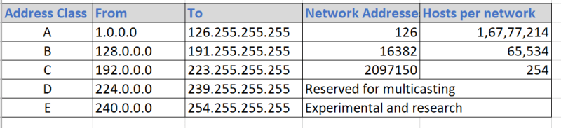
* IP Address: 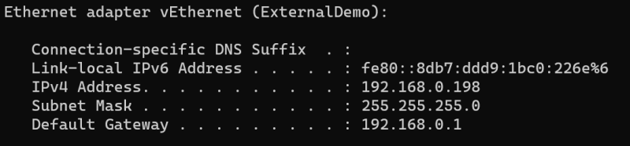
* IP Address is combination of two addresses network id and host id. Just by looking at ip address we cannot specify what is network id and what is host id

ip: 192.168.0.10

* To determine network id and host id we need subnet mask

ip: 192.168.0.10

sm: 255.255.0.0

nid: 192.168.0.0

hid: 0.10

network size => number of hosts that can be connected to this network

hid size => 2 octets => 16 bits => 2^16-2 (one for network id and one for broadcast address) => 65536-2 => 65534

ip: 10.11.25.10

sm: 255.255.255.0

nid: 10.11.25.0

hid: 10

network size => 1 octet => 2^8-2 => 254

ip: 172.16.0.9

sm: 255.255.255.0

nid: 172.16.0

hid: 9

network size=> 1 octet => 8 positions => 2^8-2 => 256-2 =>254

* If we follow this convention we have 3 possible networks

network 1 SM => 255.255.255.0 => Network size = 254

network2 SM => 255.255.0.0 => 65534

network 3 SM => 255.0.0.0 => 16777214

* Scenario: In my office network i want to connect 500 devices
  + So as per the above ip addressing you have to go with network 2 which is of size 65534 whereas we require only 500 devices
  + Other approach can be create two networks of size 254 each
* Now Lets under CIDR (Classless Interdomain routing) addressing scheme
* Till now we are looking at SM octets as decimal, if we start looking at SM as binary numbers

ip: 192.168.0.10

SM => 11111111.11111111.11111111.00000000

n/w size => 2^8-2 = 254

cidr => 192.168.0.10/24

ip: 192.168.0.10

SM => 11111111.11111111.11111110.00000000 => 255.255.254.0

n/w size => 2^9-2 => 512-2 => 510

cidr => 192.168.0.10/23

ip: 192.168.0.10

SM => 11111111.11111111.11111000.00000000 => 255.255.248.0

n/w size => 2^11-2 => 2048-2 => 2046

cidr => 192.168.0.10/21

ip: 192.168.34.193

SM: 255.255.255.240

SM: 11111111.11111111.11111111.11110000

n/w => 2^4-2 =>14

cidr: 192.168.34.193/28

* How does two systems in a network know that they belong to the same network?
  + Two systems are considered to be in a same network when their n/w id is same 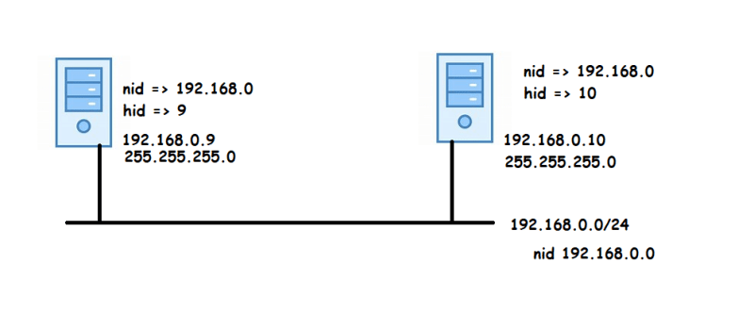
* Basic Networking rule: A system can communicate with other systems in the same network. Network packets can travel only with in a network
* Two networks cannot communicate directly, we need a router to forward packets from one network to other 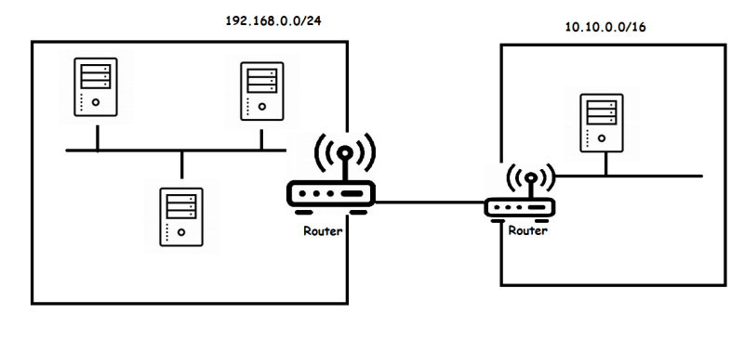
* In the ip config we have the default gateway is the ip address of the router.